Assignment - 4

## **SAS Code**

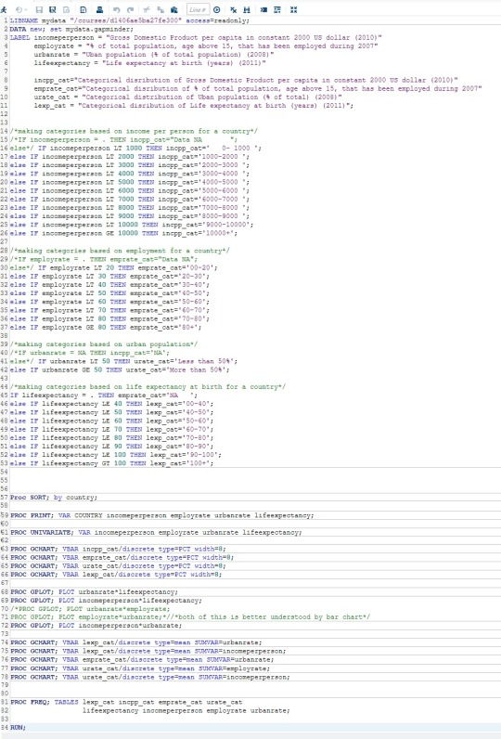

## **Univariate Procedure - Incomeperperson**

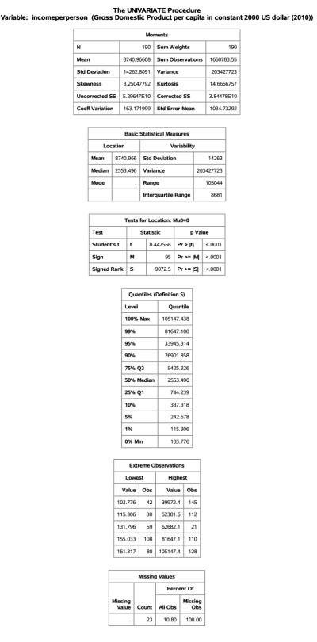

## 

## **Univariate Graph - Income per person Categorical (incpp_cat)**

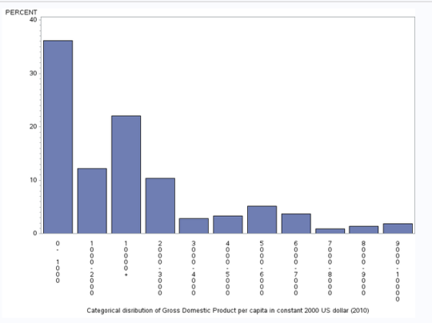

This graph is skewed towards the right as it has higher frequency in the lower categories than in the higher categories. This is following almost like decreasing trend while going towards higher categories with some small peaks occurring in between. Also this graph is missing 23 values among the 213 values of the countries.

## 

## **Univariate Procedure - EmployRate**

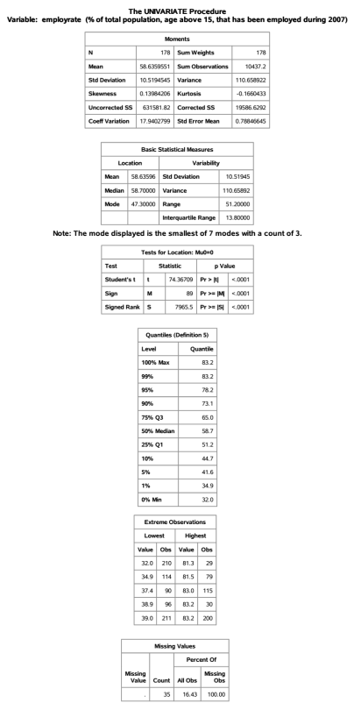

## 

## **Univariate Graph - EmployRate Categorical (emprate_cat)**

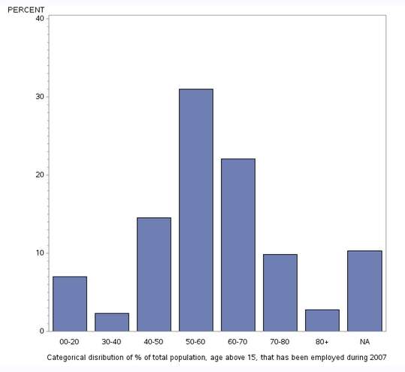

This graph seems to be almost centro symmetric with the highest frequency at around the median values. This is following trend somewhat like that of a gaussian curve like. Also this graph is missing 35 values among the 213 values of the countries which are here represented by NA i.e. Not Available.

## 

## **Univariate Procedure - UrbanRate**

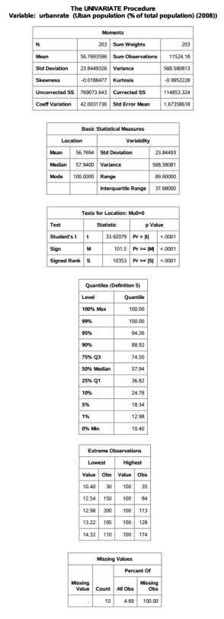

## 

## **Univariate Graph - UrbanRate Categorical (urate_cat)**

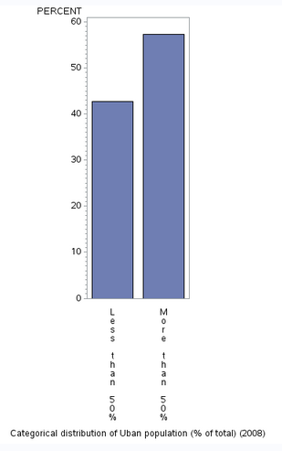

With only two category defined for this, and observing the graph it can be said that this plot if skewed towards lest that is it has higher frequency in the ‘more than 50%’ portion. This signify that more no. of countries has more of its population living in urban area.

## 

## **Univariate Procedure - LifeExpectancy**

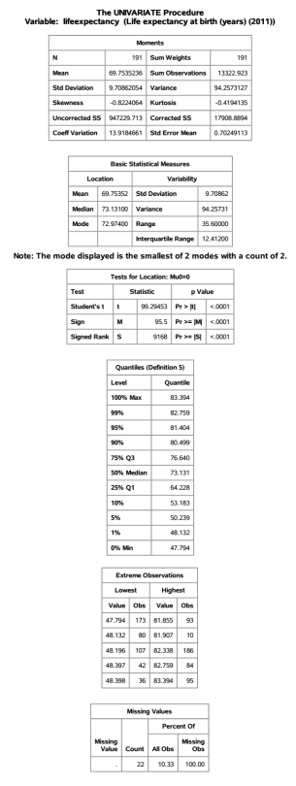

## 

## **Univariate Graph -LifeExpectancy Categorical (lexp_cat)**

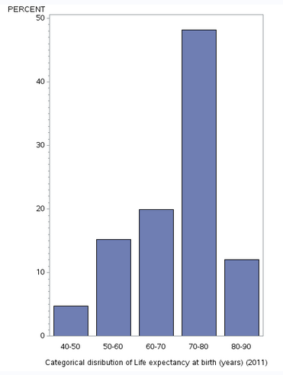

This graph is skewed towards the left as it has higher frequency in the higher categories than in the lower categories. This is following almost like an increasing trend while going towards higher categories to a limit then it falls down. Also this graph is missing 22 values among the 213 values of the countries. This is a unimodal graph which symbolizes that the large mo. of countries have life expectancy at birth of around 70 to 80 years.

## 

## **GRAPHS**

## **UrbanRate vs LifeExpectancy**

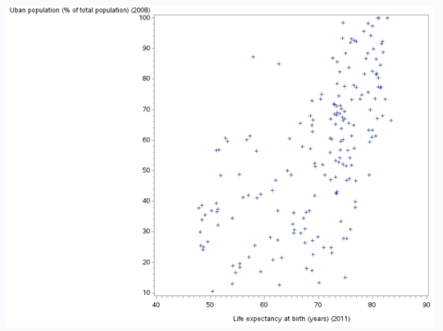

From this scatter plot we can see that countries that are having higher urban population % has higher life expectancy at birth i.e. the chances of living a long life is more in a country where more population lives in urban areas,

## 

## **IncomePerPerson vs LifeExpectancy**

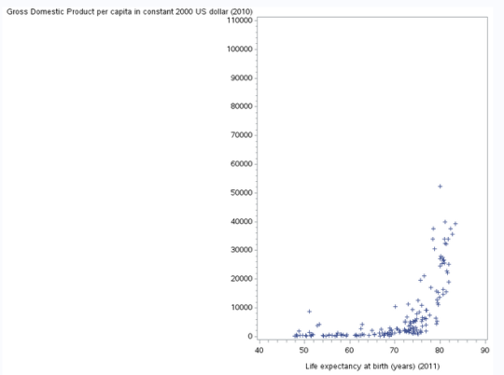

From this scatter plot we can see that countries that are having higher income per person are having higher life expectancy at birth i.e. the chances of living a long life is more in a country Which has higher income per person, Also life expectancy shows large variability for the countries having low income per person.

## **IncomePerPerson vs UrbanRate**

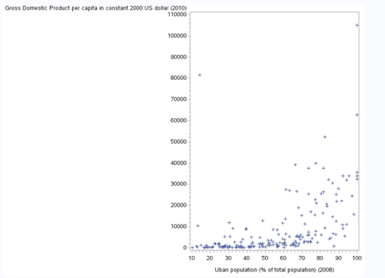

From this scatter plot we can see that countries that are having higher income per person are having higher percentage of urban population i.e. more percentage of people are living in urban areas of the countries which have higher income per person, Also life urban rate shows large variability for the countries having low income per person. Also there are some good exception present in this.